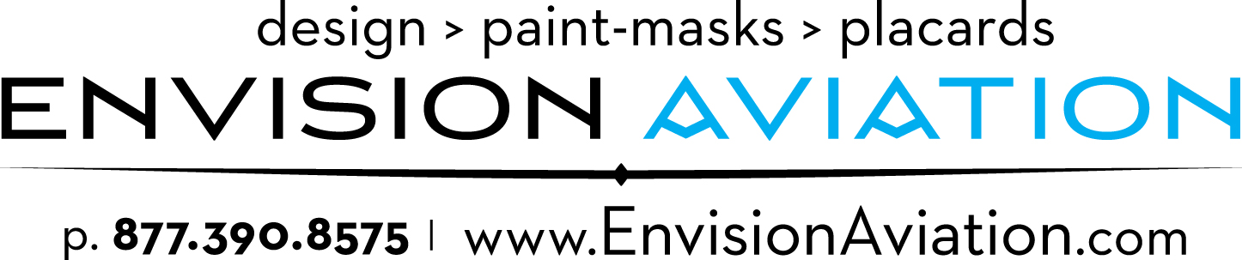

Envision Aviation®

704 Abercorn St.

Savannah, GA 31401

P: +1.877.390.8575

F: +1.800.847.7350

http://www.EnvisionAviation.com

FOR IMMEDIATE RELEASE

Envision Aviation® Unveils World’s First Painted Carbon Fiber Designed Gulfstream G650
Envision Aviation’s next generation aircraft - with Paint-Mask technology!

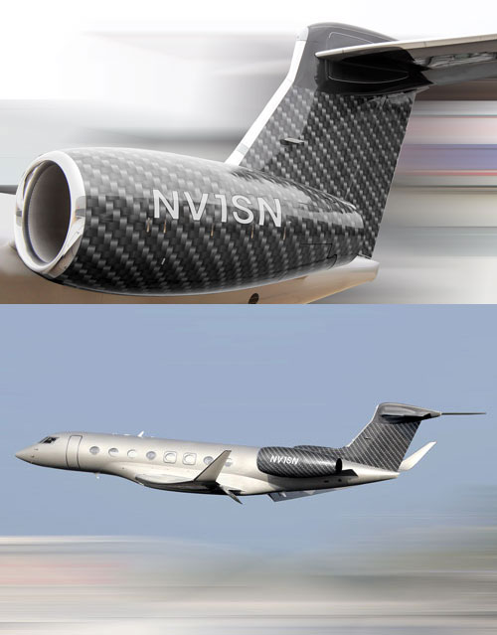
SAVANNAH, GA—Envision Aviation®, the leading designer and producer of specialized projects for all private and commercial aircraft is introducing the first ever custom painted carbon fiber design. The company, which prides itself on crafting one-of-a-kind unique schemes has partnered with O&O European Design out of Warsaw, Poland to showcase their innovative new product on a Gulfstream G650.

“When I first conceptualized the carbon fiber idea to a client, it was an immediate hit. The only problem was I ran into complications trying to achieving a real-world version with a real-world timeline,” says Marek Olko, CEO of O&O European Design. “I am thrilled to collaborate with Envision Aviation® to create and deliver any concept a client desires while delivering a finalized product and simplifying maintenance.”

“After meeting Heath Moore, CEO of Envision Aviation®, I knew his talent and level of expertise was just what Marek was looking for to seamlessly produce complex designs to meet client needs.” Kevin Locovozzi, President, DS Aviation.

At its base level, the custom design is made from a quarter of a billion company logos that when merged together create an intrinsic pattern of carbon fiber building blocks. The two-tone, two-color build of the carbon fiber is much like pointillism in a fine art painting. The process of carbon fiber begins with the application of a single base color upon which millions of logos are installed as the negative stencil paint-mask. The process is finalized by applying a second color over the first base color and the negative stencil paint-mask. After removing the stencil the final look is revealed producing the perfect carbon fiber look. Close up views of the aircraft allow you to see the base level logo of the company that purchased the aircraft adding a level of subliminal messages to the overall design.

The patent-pending custom carbon fiber design consists of a multiphase front-end loading process that expedites its onsite installation time to a minimalistic time frame consisting of only a few days. This entire paint-mask scheme is originated from a specialized repeatable and repairable design that leaves nothing but paint on the aircraft allowing the warranty of the paint to stay intact.

SPECIFICATIONS:
-Aircraft: Gulfstream G650
-Material: Axalta Coating
-Colors: Slate Gray (828259) & Silver Hinde Pearl (816826)
-Owner: Jet Story, Poland
-Concept: O&O European Design, Marek Olko
-Design/Install: Envision Aviation
-Location painted: Jet Aviation, Basel Switzerland

Download Hi-Res Images, logos

About Envision Aviation®:

Envision Aviation is a custom designer and producer of specialized projects for all private and commercial jets, helicopters, yachts and more. We have over a decade of experience with almost any kind of customization to fit almost any need.

We produce some of the world's most unique paint-schemes and designs, from in-house production to paint-masks and installation. We have multiple PATENT-PENDING systems based around our painting schemes production to and other technologies.

We can design, create and produce anything that you can Envision.

For more information about any of Envision Aviation’s services, call +1877.390.8575 or visit

www.EnvisionAviation.com

O&O European Design

Tel. +48 601 334 407

Email. m.olko@oo-design.pl

www.oo-design.pl

DS Aviation Services, Inc.

Tel. +1 912 898 2100

Email. kevin@DSAVN.com

www.DSAVN.com

Jet Aviation

Tel +41 58 158 4111

www.jetaviation.com/basel

